BMS Institute of Technology and Management

(An Autonomous Institution, Affiliated to VTU, Belagavi)

**Department of Master of Computer Applications**

(Accredited by NBA, New Delhi)

**Alternate Assessment Tool (AAT)**

|  |  |  |  |
| --- | --- | --- | --- |
| **USN** | **22MCA46** | **Student Name** | **Shreya Naik** |
| **Course Code** | **22MCA106** | **Course Title** | **Python Programming** |
| **Semester** | **1st Sem** | **Academic Year** | **2022-23** |
| **Date of**  **Submission** | **-05-2023** | **Number of Pages**  **Submitted** |  |

|  |
| --- |
| **AAT Question or Topic or Problem Statement**  **1. Write a program to calculate area of square and rectangle.**  **2. Write a program to perform string concatenation.**  **3.Write a program to read c character in upper case and print it in lower case.**  **4.Write a program to calculate simple interest and compound interest.**  **5. Write a program to calculate salary of an employee given his basic pay (to be entered by the user), HRA=10% of basic, TA=5% of basic. Define HRA and TA as constants and use them to c calculate the salary of the employee.**  **6.Write a program to take input from the user and then check whether it is a number or a character. If it is a character, determine whether it is in uppercase or lowercase.**  **7.Write a program to reverse a number.**  **8.Write a program to print the multiplication table of n, where n is entered by the use.** |
| **Solution / Answer** |

**1. Write a program to calculate area of square and rectangle.**

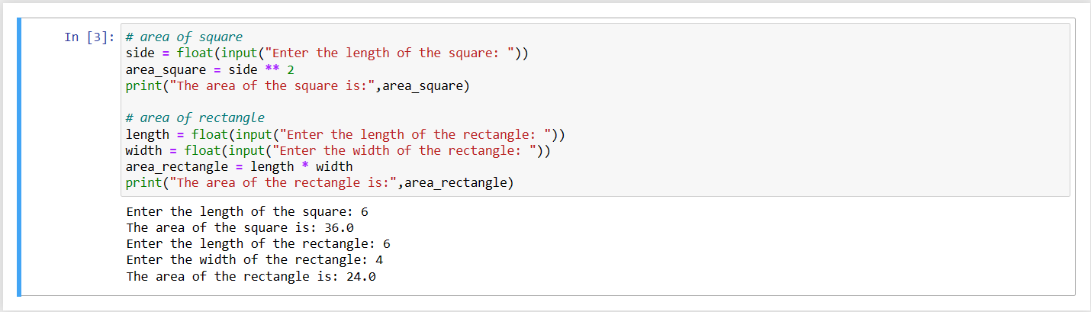

**____________________________________________________________________________________**

**2. Write a program to perform string concatenation.**

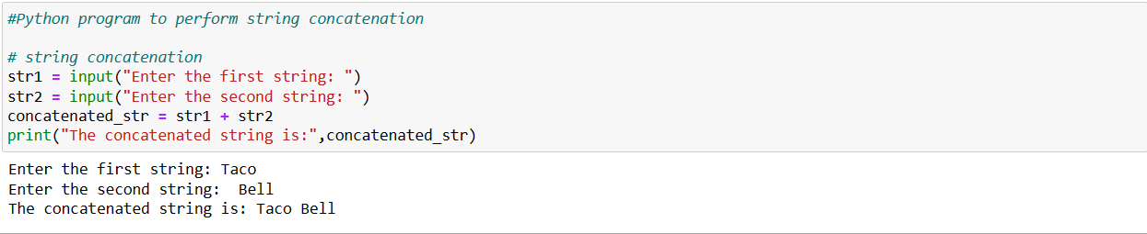

**3.Write a program to read c character in upper case and print it in lower case.**

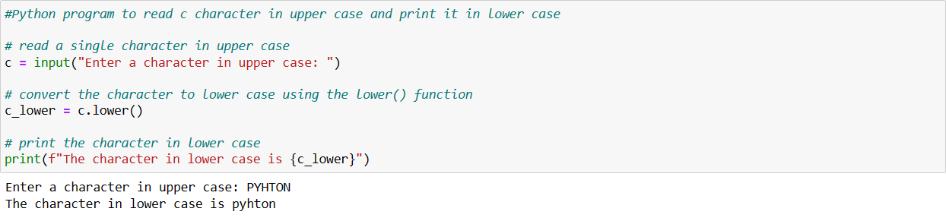

**____________________________________________________________________________________**

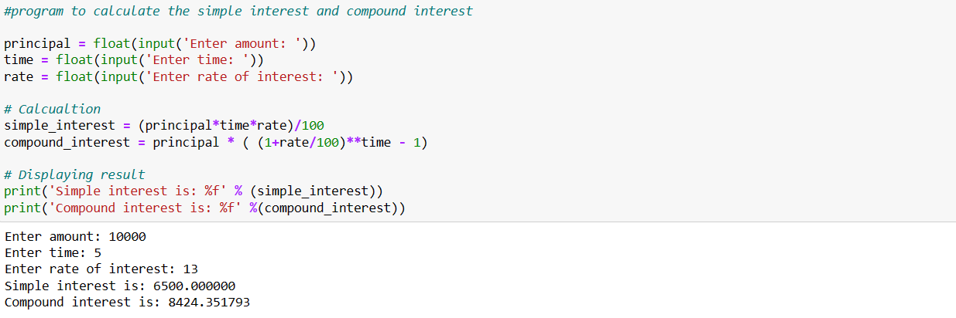**4.Write a program to calculate simple interest and compound interest.**

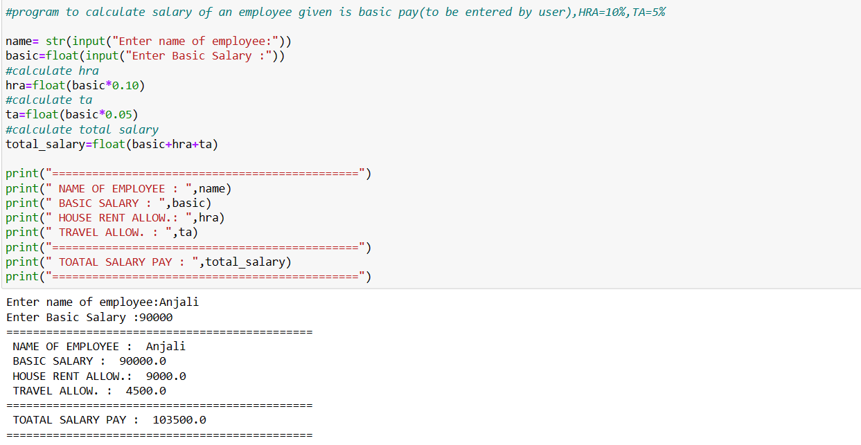**5. Write a program to calculate salary of an employee given his basic pay (to be entered by the user), HRA=10% of basic, TA=5% of basic. Define HRA and TA as constants and use them to c calculate the salary of the employee.**

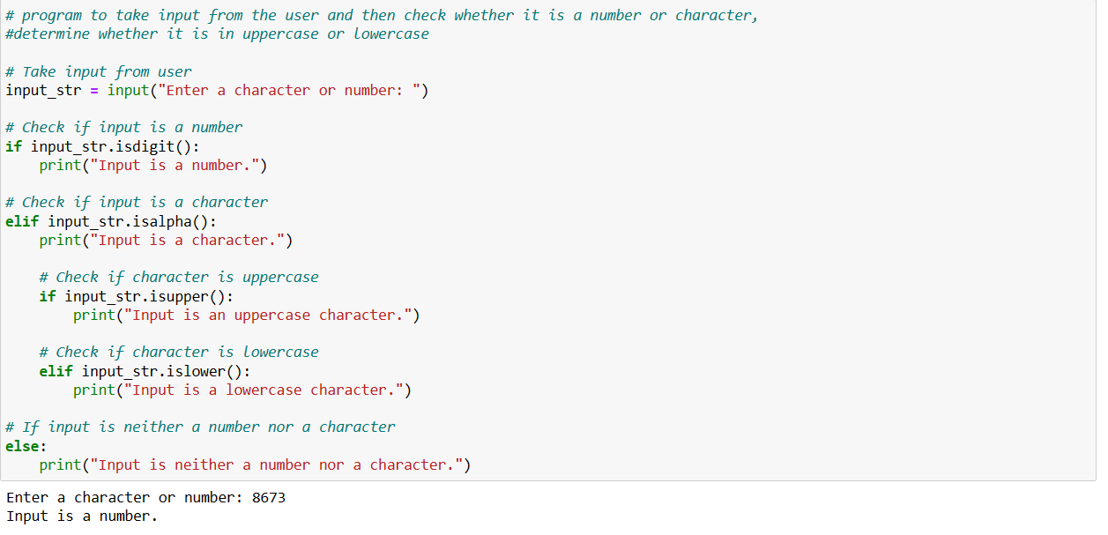**6.Write a program to take input from the user and then check whether it is a number or a character. If it is a character, determine whether it is in uppercase or lowercase .**

**7.Write a program to reverse a number.**

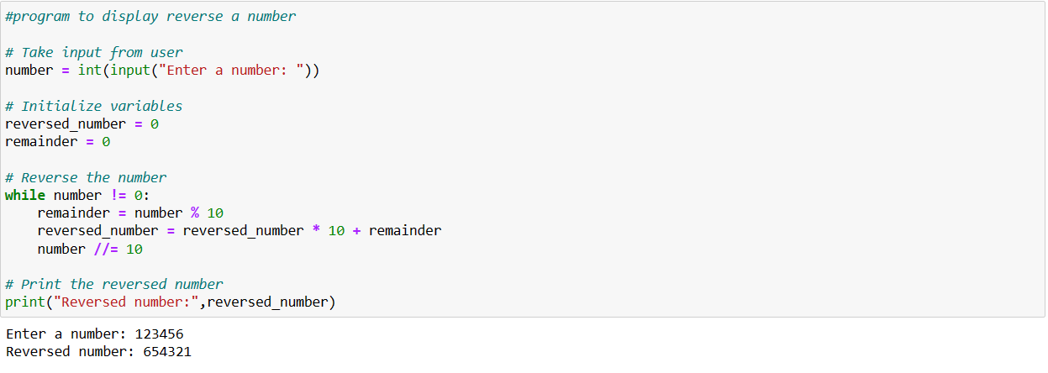

**____________________________________________________________________________________**

**8.Write a program to print the multiplication table of n, where n is entered by the use.**

